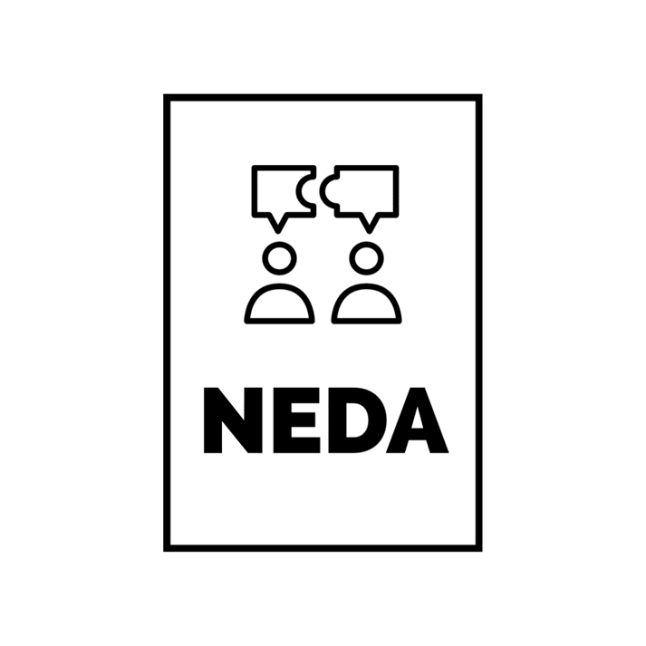
On behalf of the Wayne State University Debate Team, I’m happy to invite you to the 2026 NEDA Motor City Invitational debate tournament to be held at Wayne State University Friday and Saturday, October 9 – October 10!
We’re looking forward to exploring this year’s NEDA Resolution: The International Criminal Court does more harm than good. The tournament will also include a ‘Rapidfire/IPDA’ division debating a variety of resolutions. In addition, we have reduced our entry fees (we know it’s tough out there)!
We’re looking forward to seeing you in the Motor City in October!
Sincerely,
Ronald J. Stevenson, Ph.D.
Director of Forensics / Professor
Department of Communication
Wayne State University

Tentative Schedule
Friday Oct 9
Rd. 1 – 4pm
Rd. 2 – 5pm
Dinner (provided) – 6pm
Rd. 3 – 7pm
Saturday Oct 10
Rd. 4 – 9am
Rd. 5 – 10am
Rd. 6 – 11am
Lunch (provided) – Noon -1pm
Semifinals – 1:30pm
Finals – 3:00pm
Awards – 4:30pm

TOURNAMENT RULES:
- Teams will be competing in Public Forum/Crossfire, and IPDA/Rapidfire divisions
  - Depending on the number of teams, Varsity and Novice teams might face each other in rounds; teams will be separated by division for awards and final rounds.
  - Individuals competing in IPDA will have their topic presented to them at the round start time on the schedule and then be given 30 minutes to strike topics with their opponents and prepare their speech.
  - IPDA debaters can use computers/devices to research before the round but should not be researching once the debate has started.
  - Coaches may assist debaters during the 30-minute prep time process.
- Awards
  - Team awards will be given to the top 5 teams in each division
  - Speaker awards will be given to the top 5 individual debaters in each division
  - Sweepstakes Awards will be given to the top 3 teams.

ENTRIES:
  - Please enter team info on TabRoom.com
- All entries are due by 11pm Monday, October 5, 2026.
  - (If you don’t have exact final entries, please at least email a rough head count)
- When entering team information, please indicate whether each debater is a Novice
  - NEDA novice status = fewer than 6 previous tournaments at any level (including high school)
- Any dropped entries after 11:59p on Wednesday, October 7, will be fined a $30 penalty
- Please limit your entry to one maverick per division in Public Forum.

REGISTRATION:
- Registration will be in the lobby Manoogian Hall beginning at 3:30 Friday.
- Registration fees:
  - Public forum/crossfire: $45 per entry
  - Rapidfire: $25 per entry.
  - If registration fees are a barrier to your team’s participation, please let us know and we can make arrangements to resolve that problem.
  - There will be a $50.00 ‘judge fee’ for each uncovered team
    - Each judge provided by a school ‘covers’ two team entries

Directions:

I-75 (from the south)
- Take I-75 north and exit at Warren. Go to the light and turn left.
- Proceed on Warren for about 2 miles until you pass Anthony Wayne Drive. Turn right at the next light onto service drive (Manoogian Hall will be immediately to your right) and past the building and enter the parking structure on your right.

Parking:
Parking structure 2 is located next to Manoogian Hall. Street parking is also available, but please be mindful of your meter as the parking police aggressively enforce them even on Saturday.

Nearby Hotels:

There are a number of hotels downtown, however, those generally tend to be expensive. If you stay in Warren, Dearborn, Allen Park, or Southfield, those hotels will be about a 15–20-minute drive to the campus and are much more reasonably priced.

Avid Hotel
11570 E ELEVEN MILE ROAD,
Warren, MI, 4808
Phone: (586) 300-4200

Holiday Inn Express & Suites
Address: 30000 Van Dyke Ave,
Warren, MI 48093
Phone: (586) 573-7600

WoodSpring Suites Detroit Madison Heights
Address: 32400 Stephenson Highway,
Madison Heights, MI, 48071
Phone: (248) 607-6230

